Pediatric Magnet Ingestion, Diagnosis, Management,
and Prevention: A European Society for Paediatric
Gastroenterology Hepatology and Nutrition (ESPGHAN)
Position Paper
*†A.A. Nugud, MBBS, MRCPCH,, *†Christos Tzivinikos, MD, MSc,, ‡AmitAssa, MD, MHA,
§Osvaldo Borrelli, MD, PhD, ∥Ilse Broekaert, MD, ¶Javier Martin-de-Carpi, MD, PhD,
#Marco Deganello Saccomani, MD, PhD, **Jernej Dolinsek, MD, PhD, ††M. Homan, ‡‡Emmanuel Mas, MD, PhD, §§ErasmoMiele, MD, PhD, ∥∥Mike Thomson, MD, PhD, ¶¶MarcA. Benninga, MD, PhD, and The Gastrointestinal Committee of ESPGHAN

ABSTRACT
Magnet ingestion is a special category of foreign body ingestion associated with high levels of morbidity and mortality worldwide, particularly if it is associated with staggered ingestion of multiple magnets or with simultane- ous ingestion of other metallic foreign bodies, especially button batteries. A special category of magnet ingestion is the ingestion of earth magnets, which have higher levels of magnetism and therefore, potentially, carries a worse outcome.
Legislative bodies, scientific Societies and community-led initiatives have been implemented worldwide with the aim of mitigating the effects of this growing, yet avoidable potential medical emergency.
A scoping literature review summarized epidemiology, diagnosis, manage- ment, and prevention, including an algorithm for the diagnosis and man- agement of magnet ingestion is presented and compared to previously published reviews and position papers (North American Society of Pediatric Gastroenterology, Hepatology and Nutrition, National Poison Center, Royal College of Emergency Medicine). The main emphasis of the algorithm is on identification of staggered/multiple magnet ingestion, and early joint gas- troenterology and surgical consultation and management.
KeyWords: children, foreign body, magnet ingestion, magnets, neodymium magnet, rare-earth magnets
(JPGN2023;76: 523—532)

oreign body (FB) ingestion isnot an uncommon problem in pedi- atrics and may result in serious consequences without appropri- ate and timely intervention. Various types ofFB have been reported in the literature, with the vast majority passing spontaneously with- out any major sequelae. The American Association of Poison Con- trol Center Toxic Exposure Surveillance System identifies FBs as 1 of the top 5 hazardous human exposures in children under 5 years of age (1). High-powered neodymium magnets contain commonly rare earth elements, which are often arranged in crystalline-like alloys, such as tetragonal Nd2Fe14B like buckyballs (Fig. 1). Initially these
F

Received September 5, 2022; accepted December 23, 2022.
From the *Paediatric Gastroenterology Department, Al Jalila Children’s Spe- cialty Hospital, Dubai, United Arab Emirates, † Mohammed Bin Rashid University of Medicine and Health Sciences, Dubai, United Arab Emir- ates, ‡The Juliet Keidan Institute of Pediatric Gastroenterology, Nutrition, Shaare Zedek Medical Center, The Hebrew University, Jerusalem, Israel,

What Is Known
• Magnet ingestions pose a huge health risk for all pediatric age groups, potentially leading to severe morbidity and mortality.
• Early recognition and correct management of magnet ingestion significantly reduces morbidity and mortality.
• Although many cases are reported to few several exist- ing national Poison Control Centers, the total number of cases is likely underestimated on national levels.
What Is New
• This is the first European position paper with clinical guidance, developed in order to evaluate published evidence and to address controversial topics regard- ing diagnosis and management of magnet ingestion. In most cases, a multidisciplinary approach with sur- gical and gastroenterology teams is required.
• During the COVID-19 pandemic, in several coun- tries, an increase in magnet ingestion cases has been observed.
• The European Society for Paediatric Gastroenterol- ogy, Hepatology and Nutrition proposes to form a task force aiming to prevent the morbidity and mor- tality due to magnet ingestion injuries, by promot- ing public awareness and advocating for action by European legislative bodies in order to restrict the availability of these hazardous objects.

magnets were developed in the early 1980s and they offer an impres- sive strength-to-size ratio, 5—20 times that of traditional magnets.

the §Division of Neurogastroenterology & Motility, Department of Pae- diatric Gastroenterology, Great Ormond Street Hospital, London, UK, the ∥Department of Paediatrics, Faculty of Medicine and University Hospital Cologne, University of Cologne, Cologne, Germany, ¶Hospital Sant Joan de Déu, Barcelona, Spain, the #Department of Paediatrics, Woman’s & Child’s University Hospital of Verona, Verona, Italy, the **Department

JPGN • Volume 76, Number 4, April 2023 523

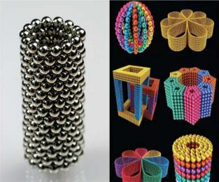

FIGURE 1. Rare-earth neodymium magnets (buckyballs) – Science Photo Library.
Compared to other types of foreign bodies, which can pass uneventfully, when multiple neodymium magnets are ingested, they can attach to each other across the walls of adjacent bowel loops due to their innate strong magnetism, and potentially causing intes- tinal necrosis, ileus, and eventually perforation (2).
The size-to-strength ratio of these magnets also plays a major role in their causation of morbidity and mortality when ingested and consequently their relatively smaller size facilitates their inges- tion in young children (3). While toddlers are the index age group, inadvertent ingestion has been reported in adolescents when used as an alternative to fake piercings, for example, lips or tongue, with equally severe outcomes reported (4).
Recommendations exist for immediate medical attention and removal in such circumstances (5—11). Despite attempts to ban con- sumer availability in various countries, millions are still sold world- wide on a monthly basis. Various management algorithms have been proposed for the diagnosis and management of magnet ingestion but to date there exists no internationally agreed consensus (11—15).
The aims ofthis European Society for Paediatric Gastroenter- ology, Hepatology and Nutrition (ESPGHAN) position paper are to highlight its increasing incidence and the need for appropriate legis- lative bodies to pass legislation in order to recall and ban the sale of these hazardous items and to provide a straightforward and practical pathway for diagnosis and management of magnet ingestion.

of Pediatrics, University Medical Center Maribor, Maribor, Slovenia, the ††Faculty of Medicine, University Children’s Hospital, University of Lju- bljana, Ljubljana, Slovenia, ‡‡Service de Gastroentérologie, Hépatologie, Nutrition et Maladies Héréditaires du Métabolisme, Hôpital des Enfants, and IRSD, Université de Toulouse, INSERM, INRAE, ENVT, UPS, Tou- louse, France, the §§Department of Translational Medical Science, Sec- tion of Pediatrics, University of Naples “Federico II”, Naples, Italy, the ∥∥Centre for Paediatric Gastroenterology, Sheffield Children’s Hospital NHS Foundation Trust, Weston Bank, Sheffield, UK, and the ¶¶Depart- ment of Paediatrics, Emma Children’s Hospital, Amsterdam University Medical Center, Amsterdam, The Netherlands.
Address correspondence and reprint requests to MarcA. Benninga, Depart- ment of Paediatrics, Emma Children’s Hospital, Amsterdam Univer- sity Medical Center, Amsterdam, 1105 AZ, The Netherlands (e-mail: m.a.benninga@amsterdamumc.nl).
Disclaimer: ESPGHAN is not responsible for the practices of physicians and provides guidelines and position papers as indicators.

METHODS
A systematic search of the literature was performed to iden- tify publications relevant to the aims ofthis position paper. A search was performed employing the following terms: (magnet AND neo- dymium magnet OR rare earth magnet AND (ingestion OR injury)). Cohort studies, cross-sectional studies, epidemiological studies, and consensus statements/guidelines published in English up to June 2022 were included. No limitation in the search period was made, and focus was placed on epidemiology, pathophysiology, complications, diagnostics, treatment (clinical presentations, imaging, endoscopy, surgery), follow-up, prevention, public awareness, and formulated clinical recommendations based on the currently available literature.

Epidemiology
Rare-earth magnet ingestion has a higher risk of morbidity and mortality compared to other types ofFBs excepting button bat- teries (BB). In parallel with BB ingestion an increase in magnet ingestion incidence has been reported over the last two decades, that is, relatively more recent than that of other FBs (11,13—27).
The annual number of cases documented worldwide has steadily increased. However, even in the United States with one of the most robust reporting systems, the true incidence appears to be under-reported due to uneventful passage through the gastroen- terology (GI) tract of the magnets of weak flux, under recognition of magnet ingestion by medical staff and under-reporting of single magnet ingestion cases, although the latter rarely causes issues (28).
Miyamoto et al reported 104 accidental magnet inges- tions across Japan between 2015 and 2017. By using the National Electronic Injury Surveillance System in the United States, mag- net ingestion cases were evaluated and focused on 2 time peri- ods—2013—2016 (post ban on sale) and 2017—2019, during which the ban on sale was lifted and there was a 32% increase in number of cases (28,29). Throughout the study period, the authors reported around 23,756 cases of suspected magnet ingestions. Of those, an estimated 3709 cases involved small/round magnets and 6100 involved multiple magnets with an annual increase through the whole study period of 6.1% cases per year. A recent analysis of the National Poison Data System from 2008 to 2019 in United States regarding magnet exposure in children <19 years of age, revealed a 444% increase in magnet injuries since 2018 (Fig. 2) (1).
In the last 2 decades, several published reports have shown that rare-earth magnets, also known as neodymium, often marketed as toys, are associated with worse outcomes compared to conven- tional low-powered magnets (1,2,8,12,16,17). Data from 4 pediatric surgical centers in the United Kingdom show that admissions of children with FB ingestion increased by 56% between 2016 and 2020, of which 21% of admissions were due to magnet ingestion

A.A. received last 3-years consultation and lectures fees from Abbvie and Takeda and research grants from Abbvie and Janssen. Dr Miele received last 3-years grants/research supports from Nestle Italy and Nutricia Italy and received payment/honorarium for lec- tures from Dicofarm, Ferring, and Shire-Takeda. O.B. received last 3-years consultation and lectures fees from Danone, Nutricia, and Mead Johnson. C.T. received last 3-years payment/honorarium for lectures/consultation from Sanofi, Takeda, Nestle, Nutricia, and Abbvie. Dr Broekaert, I.B., J.M-d-C., and M.A.B. received last 3-years consultation and lectures fees from Norgine, Coloplast, Takeda, Allergan, Mallinckrodt, Danone, HIPP, FrieslandCampina, Sensus, and United Pharmaceuticals. The remaining authors report no conflicts of interest.
Copyright © 2023 by European Society for European Society for Pediatric
Gastroenterology, Hepatology, and Nutrition and North American Soci-
ety for Pediatric Gastroenterology, Hepatology, and Nutrition.
DOI: 10.1097/MPG.0000000000003702

524 www.jpgn.org

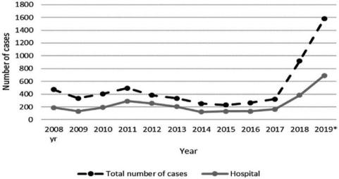

FIGURE 2. Total number of magnet exposure cases called into a US primary care clinic (PCC) and the number of cases referred to a hospital per year, 2008–2019 [adapted from Middelberg et al (1)].

(30) (Fig. 3). Magnets were responsible for 80% of all complica- tions related to FB ingestion, although an increase in all FB inges- tions was observed after March 2020 during the pandemic (32). Injuries from magnets have also been reported from aspiration and from insertion in ear, nose, genitourinary tract, rectum, but these clinical scenarios will not be addressed in this position paper.
Abbas et al (32) in the United States (2002—2011) reported that more than half of the children were younger than 5 years of age with a male predominance (31) and this was also reflected in an Australian study. In another study in the United States (2000— 2012), magnet related faux piercing injuries were more common among older children (10—15 years) (33). Other causes of ingestion identified included mistaking the magnets for sweets (6.9%) or car- rying magnets in the mouth (4.2%).

Mechanism of Injury
Compared to single magnet ingestion, the ingestion of mul- tiple magnets carries a high risk of compressing the vascular supply across bowel loops due to their mutual attraction leading to isch- emia, tissue necrosis, perforation, fistula formation, obstruction with subsequent peritonitis, and potentially death if left untreated (Fig. 4) (35). Kabre et al (36) showed that the force magnets exert

on one another increases 4-fold once the distance between the 2 magnets decreases by half.
A separate scenario involving simultaneous ingestion of a magnet and another ferromagnetic FB, for example, sharp met- als or battery, may also lead to significant GI complications. The increased risk is not only related to the pressure effect exerted across the walls of bowel loops but also associated with the addi- tional potential for electrochemical injury with BBs or tearing/ puncture damage with associated sharp metallic FBs (21). A recent meta-analysis suggested that concurrent magnet and battery inges- tion was associated with higher chances of surgical intervention compared to multiple magnets ingestion or ingestion of other types of foreign bodies (4).

Diagnosis and Management
A careful history and physical examination with a high index of clinical suspicion of FB ingestion is the mainstay of diagnosis for foreign bodies in general, and magnets in particular.
In cases of multiple magnet ingestion, the number of pieces and the ingestion interval between magnet pieces should be deter- mined. The longer the interval period and the higher the number of ingested magnets are, the greater the risk of complications is (13).

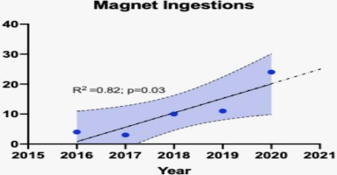

FIGURE 3. Temporal association of magnet ingestion cases in the UK 2015–2020 [adapted from Thakkar et al (30)].

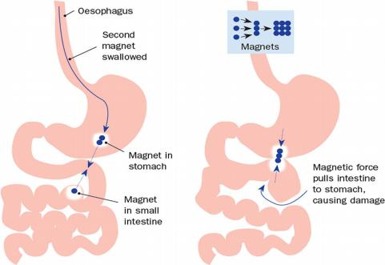

FIGURE 4. Magnets can strongly attract each other through multiple layers of bowel/gastric wall. Adapted from Kodituwakku et al (34).

Clinical Presentation
In the absence of self-admission of ingestion by the child, as with other types of FB ingestion, clinical presentation can include vomiting immediately after ingestion, recurrent cough, dysphagia, and abdominal pain. In many cases, patients are asymptomatic at the early stages post-ingestion, which is not often witnessed.

Management
A joint gastroenterology/surgical team approach is advised from the outset. Most patients presenting in emergency depart- ments with a history of witnessed or suspected magnet ingestion will be diagnosed with a plain abdominal radiograph. However, this investigation cannot always ascertain the exact number (Fig. 5) and anatomical location of the ingested magnets (34). Two or more small metallic objects seen adjacent to each other should raise concern for multiple ingested magnets. However, it is diffi- cult to define the exact position of the magnets, mainly when they are radiologically located in the upper abdomen. If the magnets are not below the level of the pelvic cavity, as indicated by abdominal X-ray, they should be considered to be potentially within upper GI endoscopic reach (12). A careful physical examination should include an assessment for signs of obstruction and perforation.
In cases of single magnet ingestion, a lateral abdominal X-ray can confirm this. In cases of failure of progression of a single mag- net within 24 hours documented by repeated abdominal X-rays, laxatives may be used to expedite passage. A computed tomography (CT) abdomen, never an magnetic resonance imaging (MRI), may be performed in some cases to better delineate the anatomical loca- tion of the magnets and identify possible complications (34,37).
In cases of single magnet ingestion, no further medical input is required if the magnet is not large enough to obstruct any portion of the bowel and not sharp in nature, unless symptoms arise (Fig. 6).
Mostafa et al reported that, in cases of double magnet inges- tions in which 2 magnets are strongly attached to each other and located in the stomach, watchful waiting can be implemented as

long as the patient remains asymptomatic without exceeding 8 hours. However, gastric ulcers may still occur even when the mag- nets are removed earlier than 8 hours (14).
In case of co-ingestion of BB, the algorithm of the ESP- GHAN position paper on BB ingestion should be followed (21,35,38) especially for ingested BB impacted in the esophagus.
Several position papers and case series have shown that the majority of multiple magnet ingestion cases are managed endoscopi- cally as soon as the magnets are assessed tobe within upper endoscopic reach. The ESGE/ESPGHAN Guidelines for Paediatric Endoscopy recommend urgent (<24 hours) removal of all magnets within endo- scopic reach (10), but we suggest removal within 6 hours post-inges- tion, based on the normal physiologic small bowel transit time (39). In case of a delay in endoscopic intervention, an abdominal X-ray may be repeated, prior to the procedure, to ensure that the magnets are still within endoscopic reach. When consenting the parents for upper GI endoscopy, the endoscopist will need to document that the magnets may not be reached or be able tobe removed during oesophago-gastro- duodenoscopy (OGD). In few tertiary centers where antegrade enter- oscopy is available may be theoretically utilized if deemed to be safe for the young age and small size of the patient (40,41)
Multiple magnets in the esophagus should raise the suspi- cion of potential concomitant aspiration and location of magnet also in trachea emphasizing the importance of an initial chest X-ray as well as an abdominal X-ray. Airway retrieval is mandatory and needs to occur quickly usually with rigid bronchoscopy by an oto- rhinolaryngology team.
Surgical magnet retrieval from the GI tract may be neces- sary if endoscopy is unsuccessful and is needed urgently when there is clinical or radiological suspicion of perforation (Fig. 7). An intramural perforation of the gastric wall discovered after endoscopic removal, without signs of gastro-enteric or -colic fistula, should be endoscopically treated with clips (Fig. 8). A close follow up to rule out pneumoperitoneum should also be instituted.
Surgical intervention is urgent when patients present with signs and symptoms of obstruction or perforation and peritonitis

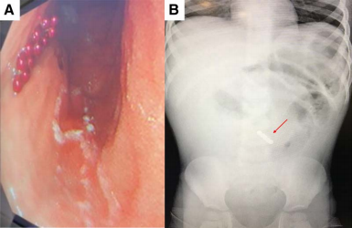
FIGURE 5. (A) Endoscopic view of ingested magnets forming a string. (B) Abdominal X-ray showing a string of buckyball magnets. The
endoscopic view revealed a greater number of magnets than on X-ray film, as the latter does not project the magnets in a three-dimensional view.

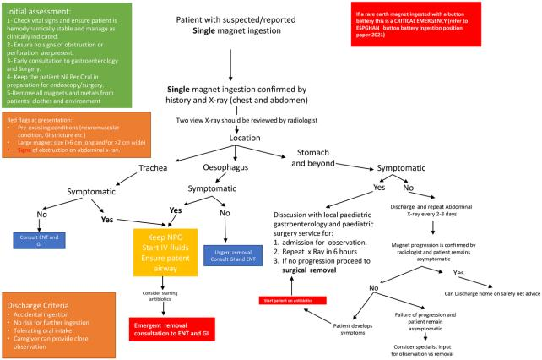

FIGURE 6. Algorithm 1: Evaluation and management of the child with single magnet ingestion.

(Fig. 9). Zhang et al (12) reported a cohort of 49 patients with mag- net ingestion, 32 of them managed surgically. The authors reported that the number of ingested magnets was higher in patients who underwent surgery compared to endoscopic management. Addition- ally, the authors recommended an urgent surgical intervention in patients who were symptomatic or those who failed a conservative

approach (laxative use, 6 hourly X-ray for progression monitor- ing), that is, failure of magnet progression through the GI tract. Inpatient osmotic laxatives may also be considered in non-symp- tomatic patients when OGD failed to detect the ingested magnets (42). For those cases who demonstrated progression, no symptoms and estimated location in the colon by X-ray a colonoscopy may be

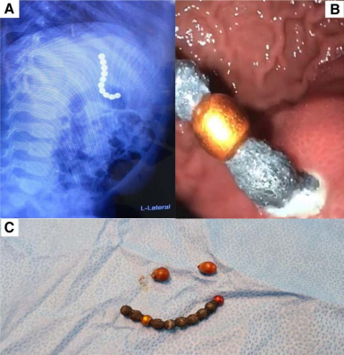
FIGURE 7. (A) Magnets string on lateral abdomen X-ray not showing signs of perforation. (B) Endoscopic evidence of intragastric perfora- tion. (C) Endoscopic retrieval of the magnets. The patient required surgery to repair perforation in both stomach and small bowel.

attempted especially if there is suspicion of concomitant magnets in the small bowel (42). The second general anesthesia and proper bowel preparation should also be taken into account.
The most common presenting symptoms for those that underwent surgery were fever, abdominal pain, and recurrent vomiting. Unsurprisingly, this resulted in a longer hospital stay of greater than 5 days.

Antibiotic Use
While there are no specific criteria for antibiotic use, in cases of multiple magnets ingestion with complications, several reports have shown a common use of broad-spectrum antibiotics, such as piperacillin/tazobactam (if no penicillin allergy) or meropenem (12). Antibiotic use is mandatory in symptomatic patients with clinical signs of obstruction or perforation and obviously in those with signs of circulatory shock and with intraoperative findings of peritonitis or purulent ascites. Initial raised CRP and/or white cell count should alert the clinician to the need for antibiotics (12).

Complications
Common complications of multiple magnet ingestion include gastric or enteric perforation, bowel ischemia, volvulus, peritonitis, fistulae sepsis, and rarely death (Fig. 10). Additionally, post-opera- tive intestinal obstruction and volvulus have been reported, neces- sitating repeating surgery often within a few days (25).
Perforations/fistulae can occur in some series in over 1-third of magnet ingestion cases with subsequent longer-term complica- tions and repeated surgical interventions (43). A 1-year-old with intractable vomiting and a FB on abdominal X-ray was reported to undergo a laparotomy revealing a 360 degrees clockwise mes- entero-axial torsion, intestinal perforation, and fistulae formation

due to ingestion of 7 rod shaped magnets (44). Additionally, the smaller the size of the ingested magnets and the longer the inter- val of staggered ingestion, the higher the risk of surgical interven- tion (45). Also, multiple reports worldwide have included deaths related to late presentation and diagnosis of magnet ingestions. Therefore, delayed decision for removal with observation >6 hours of ingested multiple magnets, which do not move on repeat X-ray, should be avoided. In case of simultaneous magnet aspira- tion, a tracheoesophageal fistula can occur (Fig. 11).
In most centers, clinicians use a similar approach for ingested magnets. In line with other proposed algorithms by the Royal College of Emergency Medicine in the United Kingdom, North American Society of Pediatric Gastroenterology, Hepatol- ogy and Nutrition (NASPGHAN) and ESPGHAN, and published cases series, Figures 11 and 12 show the proposed algorithm for cases of suspected/confirmed single and multiple magnet ingestion (6,8,10,11,46). After ensuring that the patient is vitally and hemo- dynamically stable, the next important step is to ascertain from the history the number of ingested magnets, time since ingestion, and if any other FB has been co-ingested with it, for example, sharp metals or BB.
Early pediatric surgery and pediatric gastroenterology con- sultation is always warranted in cases of multiple ingestions or staggered ingestions based on clinical and radiological investiga- tions. Additionally, the otolaryngology team should be involved if the magnets are stuck above the clavicle level or are in the upper airway tract (Fig. 10).
Prevention – Public Awareness – Legislation
In many countries, initiatives and legislative efforts have addressed the increasing number of magnet ingestion cases and

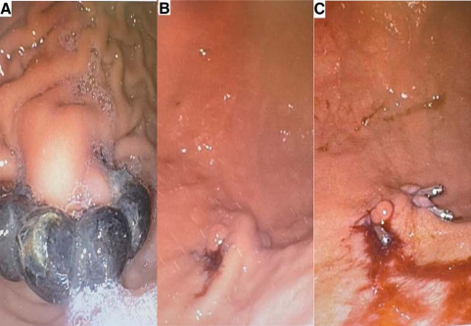

FIGURE 8. (A) Magnets perforating the gastric mucosal fold. (B) Gastric fold post magnet removal. (C) Endo-clips deployed, X-ray showed no pneumoperitoneum and patient discharged next day.

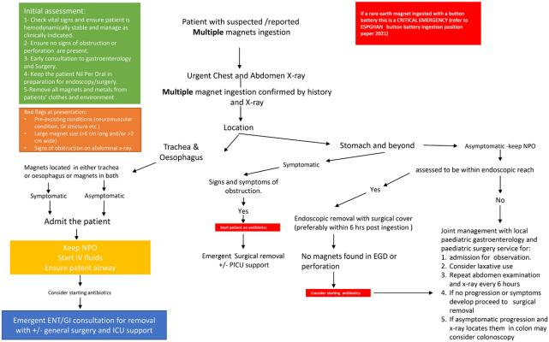

FIGURE 9. Algorithm 2: Evaluation and management of the child with multiple magnets ingestion.

their associated morbidity and mortality. In 2012 in the United States, the consumer and product safety commission (CPSC)

issued a directive that prohibited the use of loose magnets as components in children’s toys under the age of 14 years (29).

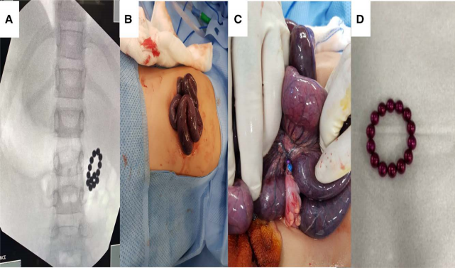

FIGURE 10. (A) String of magnets on fluoroscopic view intraoperatively. (B and C) Intraoperative images showing bowel ischemia due to ingested magnets. (D) Total of 14 magnets ingested in string formation.

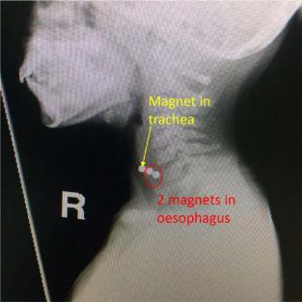

FIGURE 11. Co-ingestion of two magnets with one magnet aspira- tion located on trachea.

However the same year, a survey by the NASPGHAN showed that mandatory warning labels on toys were ineffective in reduc- ing the incidence of magnet ingestion (47). However, in 2016 the U.S. Court of Appeals for the Tenth Circuit overturned the

previous CPSC 2014 rule for high-powered magnets, and they returned to the US market (48). In August 2021, the CPSC announced a mandatory recall of 2 brands of magnets, Neoballs magnets and Zen Magnets (Zen Magnets LLC) (49) A technical review by the same US Commission proposed a new rule requir- ing a flux index of less than 50 kg2 mm2 for any magnet fitting CPSC’s small parts cylinder (42,50). This new rule has been effective since October 21, 2022 in the United States (https:// www.federalregister.gov/documents/2022/09/21/2022-20200/ safety-standard-for-magnets).
Rebranding of magnet toys as “adult table toys to reduce stress,” which may consist of around 256 small spherical rare-earth magnets that can be used to build various shapes and patterns coin- cided with an increase in the number of magnet ingestion cases in adolescent and young adults (51). Additionally, using magnets as fake piercing in adolescents led to increase in number of cases among the same age groups.
Rosenfield et al (51) showed a marked decrease in magnet ingestion cases after product recall from the market and new leg- islation that regulated vendors selling such toys between 2014 and 2015, compared to the period 2011—2012 prior to the ban.
Legislative means to limit exposure of children to the risks of ingestion of rare-earth magnets must be strengthened, for instance, via regulation of advertising online. Public health campaigning to the parents and caregivers is also essential to raise awareness of the risks of magnet ingestion in children (24).
For example, the #SafeFashion online campaign in partner- ship with the UK Office for Product Safety and Standards aims at raising awareness on different social media platforms among ado- lescents and young adults. Another example is the press release to the public and decision makers to ban selling of rare-earth magnet toys by the National Health Service-England.

Other public health campaigns for magnet ingestion in the United Kingdom are supported by agencies such as the Child Acci- dent Prevention Trust and Royal Society for the Prevention of Acci- dents (https://www.rospa.com/safe-fashion, https://www.capt.org. uk/news/magnetic-toys).
Prospective multi-center-based registries are needed to collect data on magnet ingestions ideally on a national and Euro- pean level to effectively assess the scale of the problem and the extent of complications. These data can also inform best practice guidelines for optimal diagnosis, management and outcomes, and inform legislative stakeholders. In the United States, this exists via the National Poison Center and in the United Kingdom a multi- specialty group of pediatric emergency medicine physicians and surgeons has initiated in May 2022 a prospective surveillance study
— (MAGNETIC study, https://redcapsurveys.uhbw.nhs.uk/surveys/ ?s=RNN7DKM4MKXKH3TX).

Conclusion and Recommendations
Currently, there is no specific International Classification of Diseases code for magnet ingestion, hence the true burden of the issue is not fully known. In addition, in most regions around the world, no national database for magnet ingestion exists. Without such incidence data a cogent forceful argument for legislation is constrained.
Community and accident prevention agency initiatives that raise awareness about this issue are imperative for addressing this problem, with social media influencers and dissemination of knowl- edge to the public via social media platforms as an additional platform.
We propose the formation of a dedicated ESPGHAN task force for magnet ingestions to focus on:
1. Early recognition and management of magnet ingestion, which will significantly reduce morbidity and mortality associated with this preventable problem.
2. Utility and timing of imaging.
3. Timing of and thresholds for intervention post-ingestion with- in a multi-specialist team framework.
4. Raising public and stakeholders’ awareness, which is vital in mitigating the incidence of magnet ingestions.
5. Legislation introduction for banning of these rare-earth toy products at a European level.
The ESPGHAN task force for magnet ingestions recom- mends further research on:
1. Strategies to raise public awareness about the disease and ef- ficacy of prevention strategies.
2. Early surgical intervention in complicated cases.
3. Follow-up after magnet ingestion.
4. Evaluating current guidelines in clinical practice.

SUMMARY
Patients with magnet ingestions commonly present late to the emergency department, unless in witnessed cases. Due to insidious signs and symptoms at time of presentation, the diagno- sis of magnet ingestion can be challenging. Due to the paucity of symptoms and signs, a high index of clinical suspicion of magnet ingestion is necessary in order to prevent the delay in diagnosis and management.
X-ray of the chest and abdomen is mandatory in all cases to identify magnets; however, it will not always ascertain the exact anatomical location or number of magnets. Early endoscopic removal can help mitigate the risk of complications, but a surgical team should be part of decision-making from the outset.

In case of single magnet ingestion, watchful waiting with repeat X-ray to assess the movement of the magnet through the GI tract is recommended. Delay in the diagnosis of multiple mag- nets might be associated with life threatening complications. In such cases, early surgical intervention is warranted. Moreover, the concurrent ingestion of magnets and other types of foreign bod- ies carries a higher risk of complications. Finally, while legisla- tive mandates can help reduce the burden of the issue, community awareness programs might play a pivotal role in raising general public awareness.

REFERENCES
1. Middelberg LK, Funk AR, Hays HL, McKenzie LB, Rudolph B, Spiller HA. Magnet injuries in children: an analysis of the National Poison Data System from 2008 to 2019. JPediatr 2021;232:251—256.e2.
2. McCormick S, Brennan P, Yassa J, Shawis R. Children and mini-mag- nets: an almost fatal attraction. Emerg MedJ 2002;19:71—3.
3. Fraden J. Handbook of Modern Sensors: Physics, Designs, and Applications. 4th ed. New York, NY: Springer; 2010.
4. Jayachandra S, Eslick GD. A systematic review of paediatric foreign body ingestion: presentation, complications, and management. Int J Pediatr Otorhinolaryngol 2013;77:311—7.
5. Royal Society for the Prevention of Accidents. #SafeFashion - Campaign for magnet safety. Available at: https://www.rospa.com/safe- fashion. Accessed January 24, 2023.
6. Royal College of Emergency Medicine. Best Practice Guideline: Ingestion of Super Strong Magnets in Children. May 2021. Available at: https://rcem.ac.uk/wp-content/uploads/2021/10/RCEM_BPC_ Ingestion_of_Super_Strong_Magnets_in_Children_170521.pdf.
7. USA CPSC. Zen Magnets and Neoballs Magnets recalled due to inges- tion hazard. 2021. Available at: https://www.cpsc.gov/Recalls/2021/ Zen-Magnets-and-Neoballs-Magnets-Recalled-Due-to-Ingestion- Hazard. Accessed January 24, 2023.
8. Hussain SZ, Bousvaros A, Gilger M, et al. Management of ingested magnets in children. J Pediatr Gastroenterol Nutr 2012;55:239—42.
9. UAE Ministry of Industry and Advanced Technology (MoIAT). 2022. Available at: https://gulfnews.com/uae/health/uae-ban-on-super- magnet-toys-is-helping-protect-children-doctors-say-1.84875214 . Accessed January 24, 2023.
10. Thomson M, Tringali A, Dumonceau JM, et al. Paediatric gastroin- testinal endoscopy: European Society for Paediatric Gastroenterology Hepatology and Nutrition and European Society of Gastrointestinal Endoscopy guidelines. J Pediatr Gastroenterol Nutr 2017;64:133—53.
11. Kramer RE, Lerner DG, Lin T, et al. Management of ingested foreign bodies in children: a clinical report of the NASPGHAN Endoscopy Committee. J Pediatr Gastroenterol Nutr 2015;60:562—74.
12. Zhang S, Zhang L, Chen Q, et al. Management of magnetic foreign body ingestion in children. Medicine (Baltim) 2021;100:e24055.
13. Altokhais T. Magnet ingestion in children management guidelines and prevention. Front Pediatr 2021;9:727988.
14. Mostafa MS, Darwish AA. Magnet ingestion in children and its impli- cations: tertiary centre experience. Pediatr Surg Int 2021;37:937—44.
15. Sola R Jr, Rosenfeld EH, Yu YR, St Peter SD, Shah SR. Magnet foreign body ingestion: rare occurrence but big consequences. J Pediatr Surg. 2018;53:1815—9.
16. Alfonzo MJ, Baum CR. Magnetic foreign body ingestions. Pediatr Emerg Care 2016;32:698—702.
17. HanY, Youn JK, Oh C, Lee S, Seo JM, Kim HY. Ingestion of multiple magnets in children. J Pediatr Surg 2020;55:2201—5.
18. Silverman JA, Brown JC, Willis MM, Ebel BE. Increase in pediatric magnet-related foreign bodies requiring emergency care. Ann Emerg Med 2013;62:604—608.e1.
19. Dong T, Zhao L, Fan Z. Paediatric magnet ingestion: urging for a national database. Acta Paediatr 2021;110:1967.
20. Miyamoto R, Okuda M, Kikuchi S, Iwayama H, Hataya H, Okumura A. A nationwide questionnaire survey on accidental magnet ingestion in children in Japan. Acta Paediatr 2021;110:314—25.
21. Bolton SM, Saker M, Bass LM. Button battery and magnet ingestions in the pediatric patient. Curr Opin Pediatr 2018;30:653—9.

22. Butterworth J, Feltis B. Toy magnet ingestion in children: revising the algorithm. J Pediatr Surg 2007;42:e3—5.
23. Powell B, Parsh B. Pediatric magnet ingestion. Nursing 2021;51:11.
24. The Lancet Gastroenterology H. Ingestion of high-power magnets: cause for concern. Lancet Gastroenterol Hepatol 2021;6:511.
25. Tsai J, Shaul DB, Sydorak RM, Lau ST, Akmal Y, Rodriguez K. Ingestion of magnetic toys: report of serious complications requiring surgical intervention and a proposed management algorithm. Perm J 2013;17:11—4.
26. Hodges NL, Denny SA, Smith GA. Rare-earth magnet ingestion- related injuries in the pediatric population: a review. Am J Lifestyle Med 2017;11:259—63.
27. Talvard M, Mouttalib S, Flaum V, et al. [Magnet ingestions in children: a French multicenter study]. Arch Pediatr 2015;22:32—8.
28. Reeves PT, Rudolph B, Nylund CM. Magnet ingestions in children pre- senting to emergency departments in the United States 2009—2019: a problem in flux. J Pediatr Gastroenterol Nutr 2020;71:699—703.
29. Reeves PT, Nylund CM, Krishnamurthy J, Noel RA, Abbas MI. Trends of magnet ingestion in children, an ironic attraction. J Pediatr Gastroenterol Nutr 2018;66:e116—21.
30. Thakkar H, Burnand KM, Healy C, et al. Foreign body ingestion in children: a magnet epidemic within a pandemic. Arch Dis Child 2021;106:1238—9.
31. Abbas MI, Oliva-Hemker M, Choi J, et al. Magnet ingestions in chil- dren presenting to US emergency departments, 2002—2011. J Pediatr Gastroenterol Nutr 2013;57:18—22.
32. Festa NT, Thakkar H, Hewitt R, et al. Foreign body ingestion during the COVID-19 pandemic: a retrospective single centre review. BMJ Paediatr Open 2021;5:e001042.
33. De Roo AC, Thompson MC, Chounthirath T, et al. Rare-earth magnet ingestion-related injuries among children, 2000—2012. Clin Pediatr (Phila) 2013;52:1006—13.
34. Pugmire BS, Lim R, Avery LL. Review of ingested and aspirated for- eign bodies in children and their clinical significance for radiologists. Radiographics 2015;35:1528—38.
35. Kodituwakku R, Palmer S, Paul SP. Management of foreign body ingestions in children: button batteries and magnets. Br J Nurs 2017;26:456—61.
36. Kabre R, Chin A, Rowell E, et al. Hazardous complications of mul- tiple ingested magnets: report of four cases. Eur J Pediatr Surg 2009;19:187—9.
37. Blevrakis E, Raissaki M, Xenaki S, Astyrakaki E, Kholcheva N, Chrysos E. Multiple magnet ingestion causing instestinal obstruction

and entero-enteric fistula: which imaging modality besides radio- graphs? A case report. Ann Med Surg (Lond) 312018:29—33.
38. Mubarak A, Benninga MA, Broekaert I, et al. Diagnosis, management, and prevention of button battery ingestion in childhood: a European Society for Paediatric Gastroenterology Hepatology and Nutrition Position Paper. J Pediatr Gastroenterol Nutr 2021;73:129—36.
39. Yuen KH. The transit of dosage forms through the small intestine. Int J Pharm 2010;395:9—16.
40. Yokoyama K, Yano T, Kumagai H, et al. Double-balloon enteroscopy for pediatric patients: evaluation of safety and efficacy in 257 cases. J Pediatr Gastroenterol Nutr 2016;63:34—40.
41. Urs AN, Martinelli M, Rao P, Thomson MA. Diagnostic and thera- peutic utility of double-balloon enteroscopy in children. J Pediatr Gastroenterol Nutr 2014;58:204—12.
42. Shaul E, Agawu A, Wood P, Umhoefer K, Mamula P. Management of magnet ingestions at a large tertiary care children’s hospital. J Pediatr Gastroenterol Nutr 2022;75:334—9.
43. Waters AM, Teitelbaum DH, Thorne V, Bousvaros A, Noel RA, Beierle EA. Surgical management and morbidity of pediatric magnet inges- tions. J Surg Res 2015;199:137—40.
44. Nui A, Hirama T, Katsuramaki T, et al. An intestinal volvulus caused by multiple magnet ingestion: an unexpected risk in children. J Pediatr Surg 2005;40:e9—11.
45. Rosenfield D, Strickland M, Fecteau A. Magnet ingestion by a 3-year- old boy. CMAJ 2013;185:972—4.
46. Bauman B, McEachron K, Goldman D, et al. Emergency management of the ingested magnet: an algorithmic approach. Pediatr Emerg Care 2019;35:e141—4.
47. NSPGHAN. Warning labels ineffective at preventing high-powered magnet ingestions: NSPGHAN. 2015. Available at: https://www.nasp- ghan.org/files/documents/pdfs/advocacy/2012/Final%20NOLA%20 Press%20Release.pdf.
48. Consumer Product Safety Commission. Safety standard for magnet sets; removal of final rule vacated by court. Fed Regist 2017;82:12716—7.
49. Consumer Product Safety Commission. Zen Magnets and Neoballs Magnets recalled due to ingestion hazard. 2021. Available at: https:// www.cpsc.gov/Recalls/2021/Zen-Magnets-and-Neoballs-Magnets- Recalled-Due-to-Ingestion-Hazard. Accessed January 24, 2023.
50. Consumer Product Safety Commission. Proposed rule: safety standards for magnet. Fed Regist 2022;87:1260—316.
51. Rosenfield D, Strickland M, Hepburn CM. After the recall: reexamin- ing multiple magnet ingestion at a large pediatric hospital. J Pediatr 2017;186:78—81.

